This project demonstrates how password-protected PDF files can be assessed using a hash extraction and dictionary-based password cracking. It also highlights the importance of using strong, unique passwords that are not easily found in common wordlists.
STEP 1: Download the encrypted PDF file
Download the file “My Locked PDF1.pdf” to your computer: https://networkwalks.com/project-task-lab-password-cracking-with-netwokwalks-tools


STEP 2: Generate the PDF hash
Open the Networkwalks Hash Calculator on your web browser and upload the locked PDF file. The tool will analyze the file and generate a PDF password hash beginning with $pdf$.
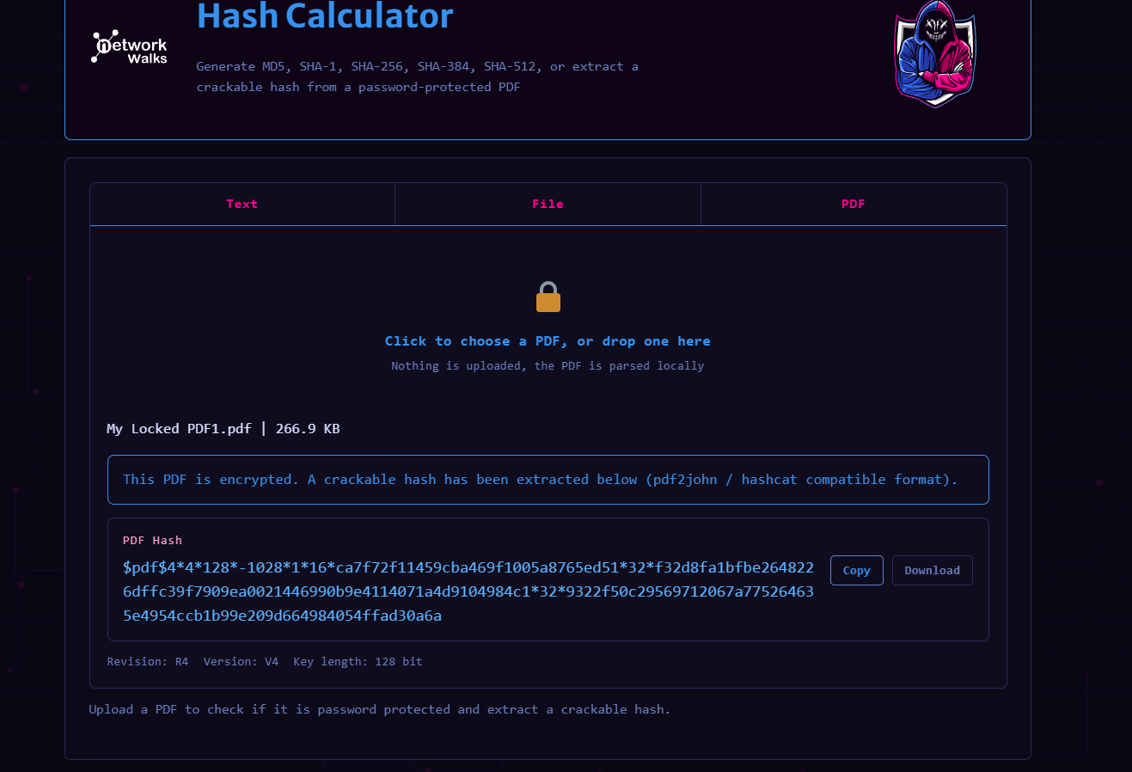
https://networkwalks.com/hash-calculator

STEP 3: copy the complete hash
Copy the entire hash value, starting from $pdf$. Make sure no characters are missing from the beginning to the end of the hash.
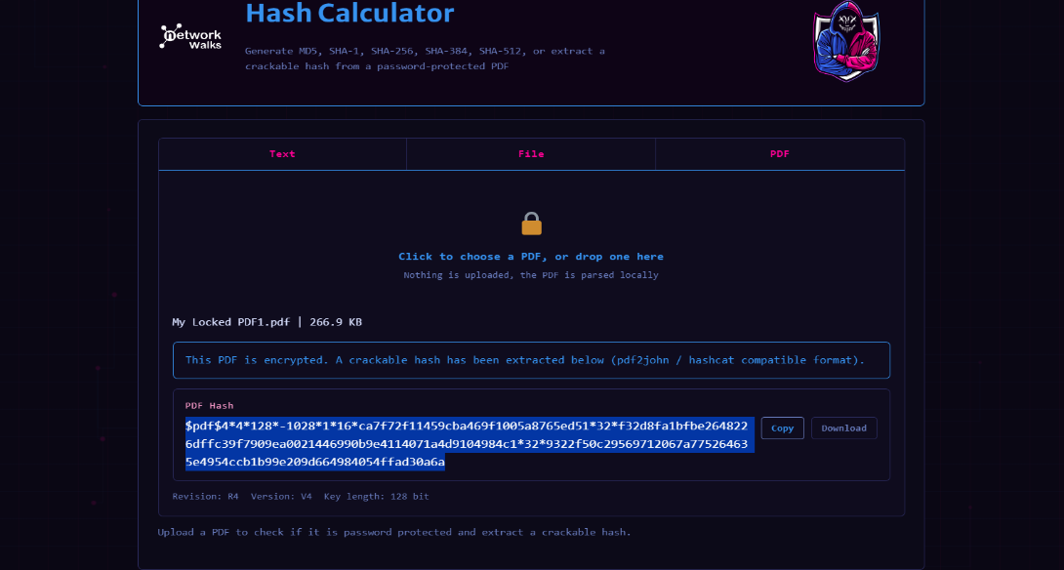

STEP 4: Open the Networkwalks Password Cracker
Open the Networkwalks Password Cracker in your browser
https://networkwalks.com/password-cracker
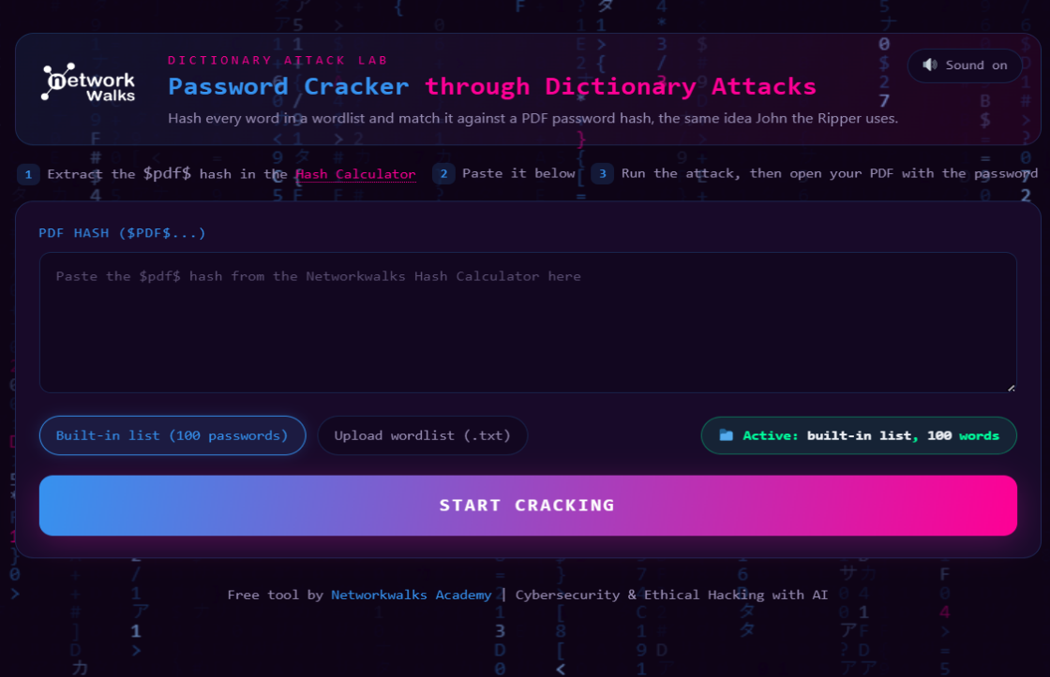

STEP 5: Start the password-cracking process
Paste the complete PDF hash into the Password Cracker and start the attack. The tool will compare possible passwords from the wordlist against the hash until it finds a matching password.
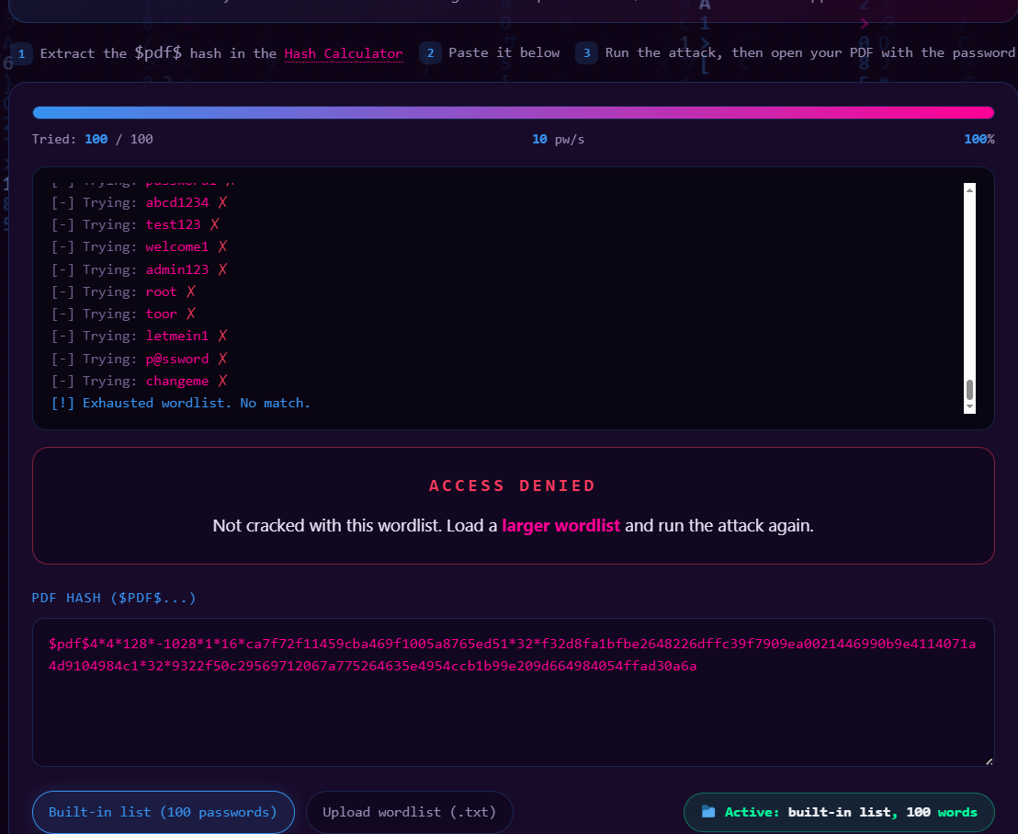

STEP 6: Expand the wordlist when necessary
Initially, the 100-word dictionary provided by default was unable to crack the password. I therefore expanded the dictionary by uploading the 3556-wordlist provided by the instructor. After using the larger wordlist, the Password Craker successfully identified the correct password.


Open “My Locked PDF1.pdf” and enter the cracked password (good-luck) when prompted. The PDF should then open successfully.


